**Introduction to Spring Boot Framework**

Use Cases Manual

Sandbox Link [Spring Boot](https://share.percipio.com/cd/J676mja_Z)

Spring Boot and Content Negotiation - XML and JSON Representations

Content Negotiation helps the Consumer and Provider interact about the data exchange format. In this article, we will expose both XML and JSON representations.

**You will learn**

* What is Content Negotiation?
* Why do you need Content Negotiation?
* How do you implement Content Negotiation with Spring Boot?
* How do you use XML representation for request and response with Spring Boot RESTful Services?
* How do you use JSON representation for request and response with Spring Boot RESTful Services?

**Tools you will need**

* Maven 3.0+ is your build tool
* Your favorite IDE. We use Eclipse.
* JDK 1.8+

**What is Content Negotiation?**

Key abstraction in REST is a Resource. There is no restriction on what a resource can be. A todo is a resource. A person on facebook is a resource.

A resource can have multiple representations

**XML**

**HTML**

**JSON**

When a resource is requested, we provide the representation of the resource.

When a consumer sends a request, it can specify two **HTTP Headers** related to Content Negotiation

**Accept and**

**Content-Type**

Content-Type indicates the content type of the body of the request.

Accept indicates the expected content type of the response.

**Implementing XML Representation for Spring Boot Services**

It’s simple. All that you would need to do is to add a simple dependency to your pom.xml.

<dependency>

<groupId>com.fasterxml.jackson.dataformat</groupId>

<artifactId>jackson-dataformat-xml</artifactId>

</dependency>

Restart your application.

**Example of Content Negotiation**

Following screen shot shows how you can specify these headers in a request using Postman.

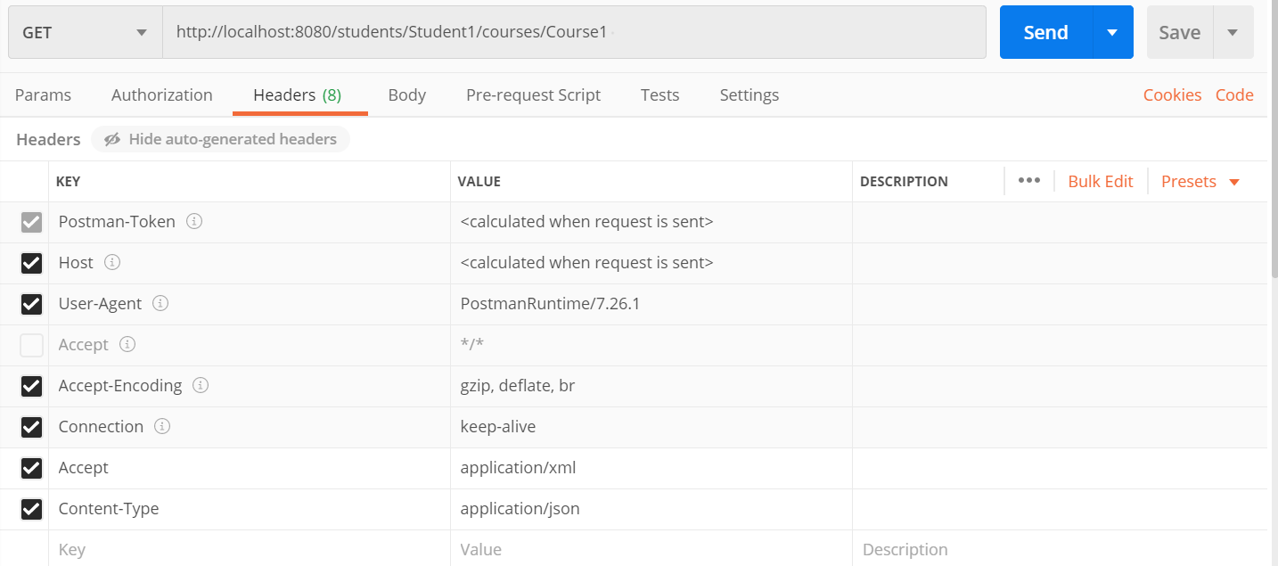

The server is expected to respond based on the Accept header.

For example, if a consumer sends a request to [http://localhost:8080/students/](http://localhost:8080/students/Student1/courses/Course1)

with Accept header as ‘application/xml’, we need to provide the xml representation of the resource.

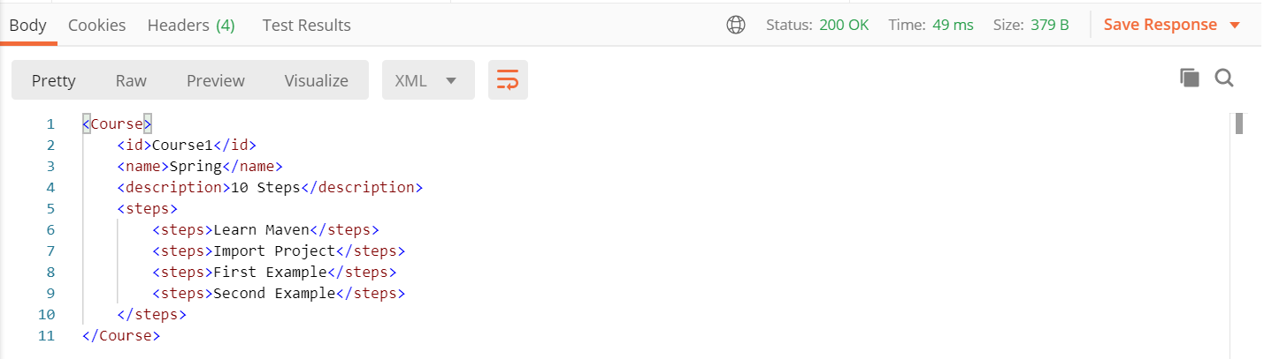

This dialog which happens between the Consumer and Service Provider is called Content Negotiation.